**TUGAS PENDAHULUAN MODUL 2**

**NAMA: WISNU SATRIO AGUNG**

**KELAS: IF-46-12**

**NIM: 1301223456**

1. 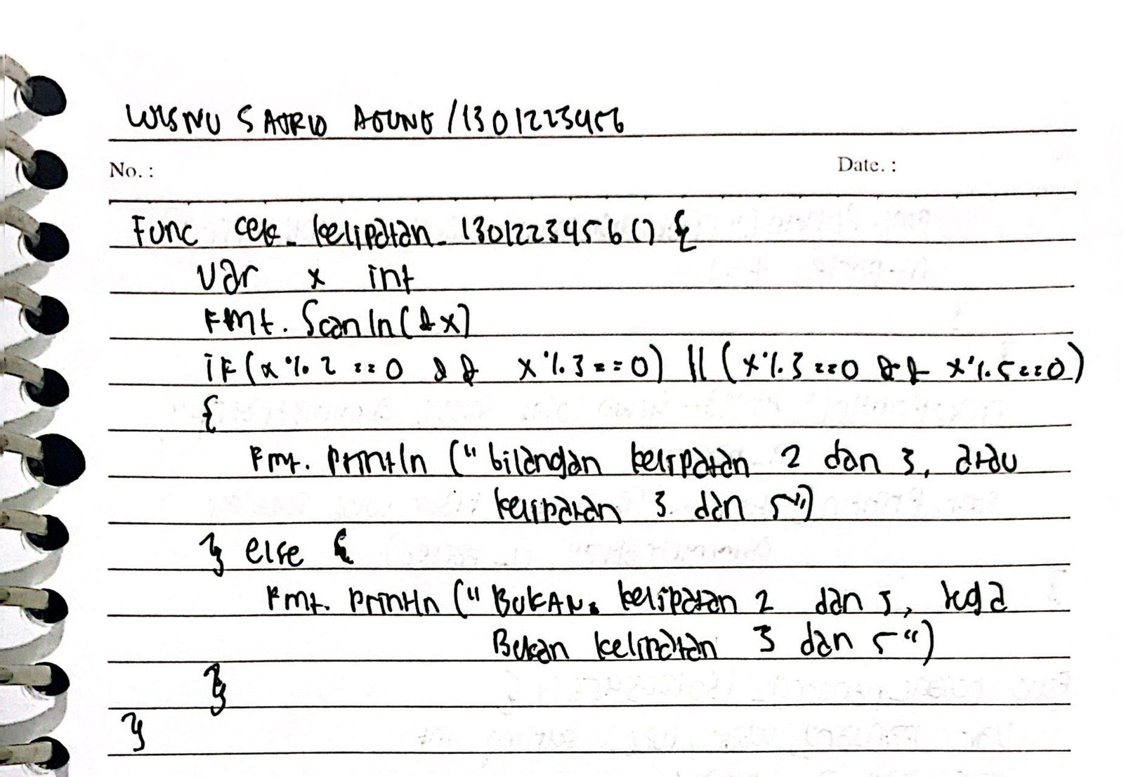
2. 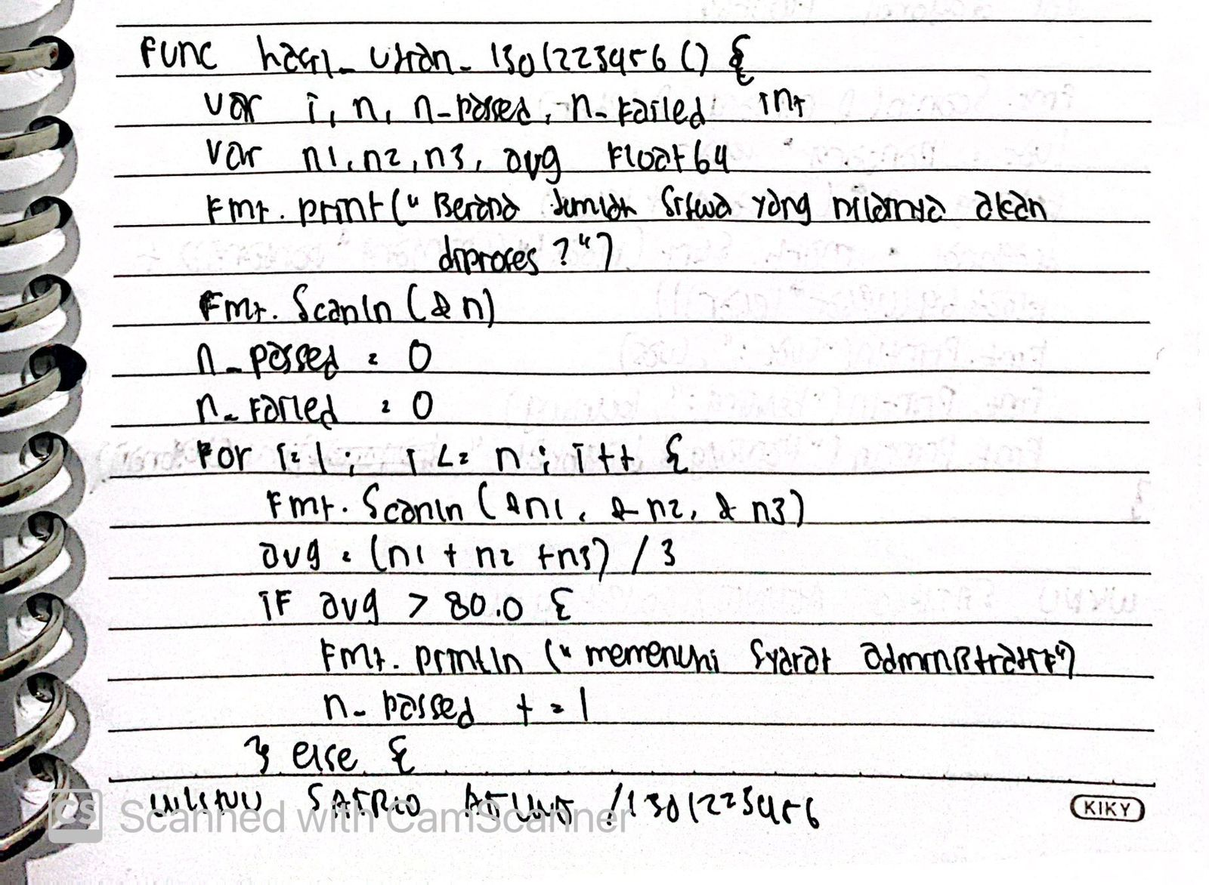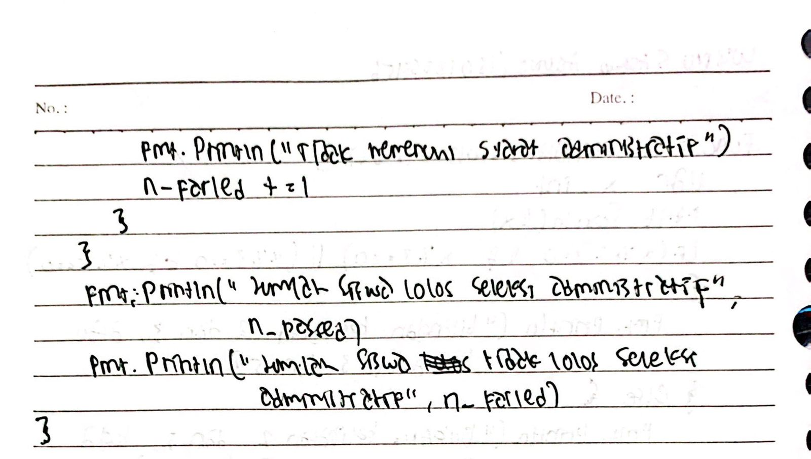
3. 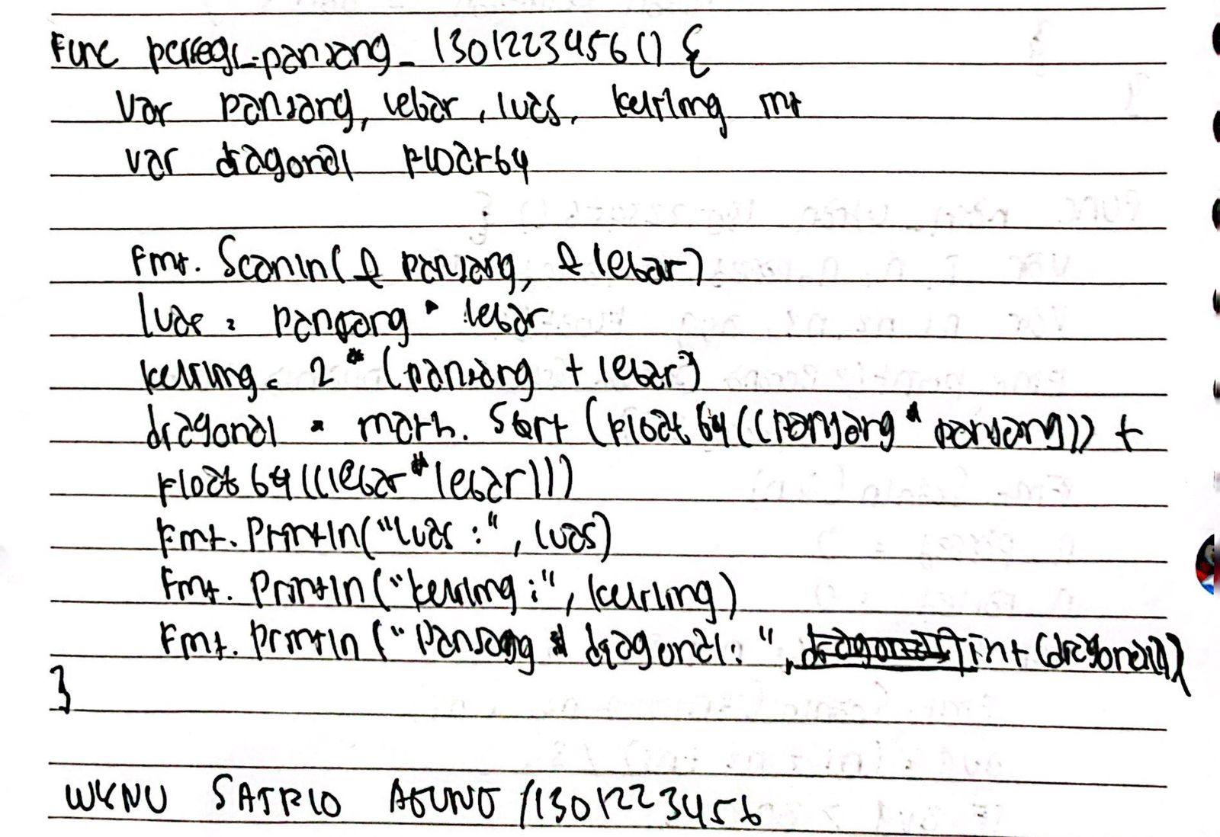
4. 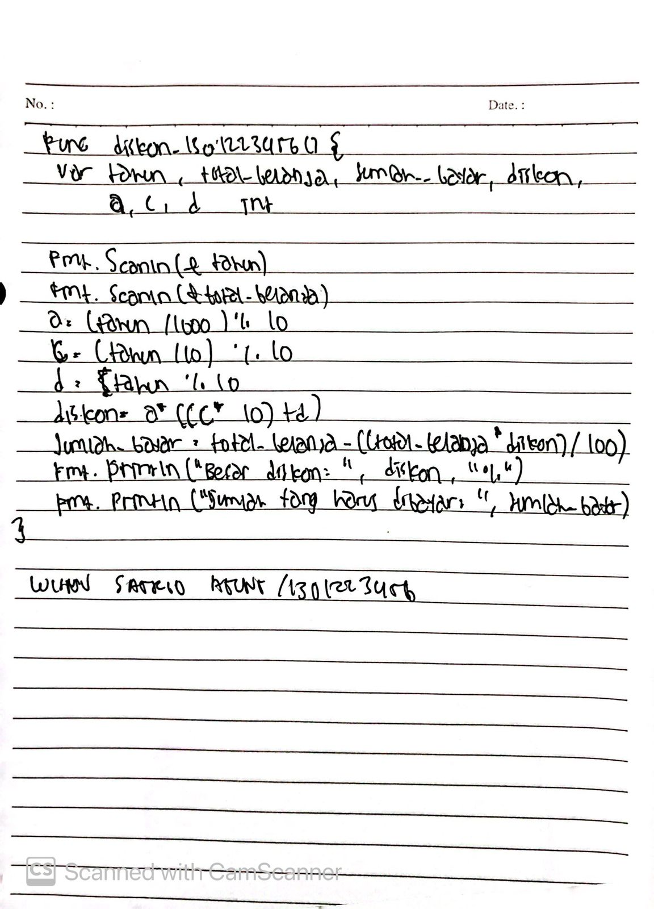

**Code:** <https://github.com/Wisnusat/kuliah_golang/blob/master/semester_2/pendahuluan.go>